Instruction:
- Start the "Command Prompt" from the Windows Start Menu (Start -> Accessories -> Command Prompt).
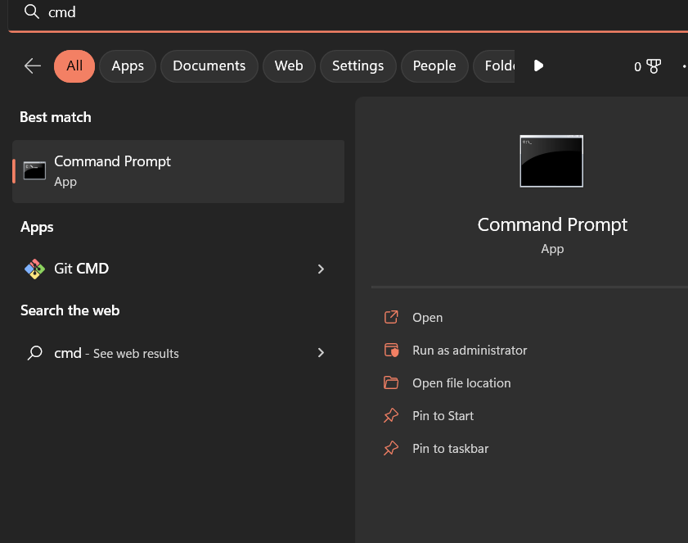

- Use cd, cd.., cd/.. commands to navigate through the directories
Create the Directory HCK in the desktop.
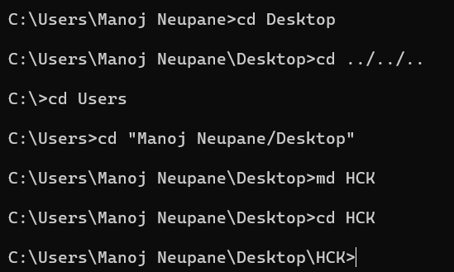
3. List the files in the current directories. Make use of commands cls, exit to clear the screen and exit the prompt.
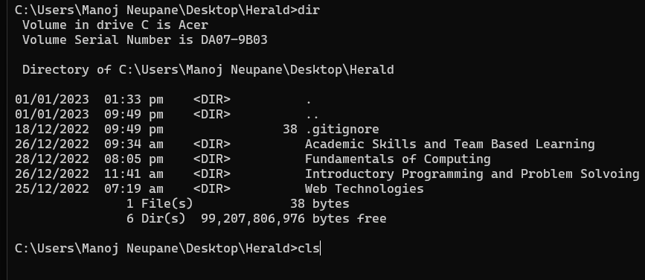
After CLS, the screen is cleared, and the exit command is entered.
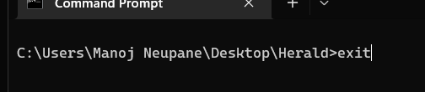

4. Create New.txt file containing text “Herald College Kathmandu”, in the HCK directory.
5. Delete New.txt file from HCK directory.
6. Remove directory HCK form the Desktop.
4, 5 and 6
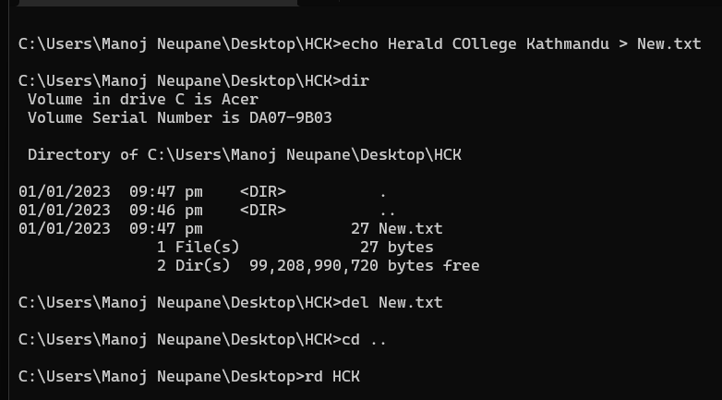

7. Create directory Kathmandu in the desktop containing file Swyambhu.txt, Rename Swayambhu.txt as Barahi.txt
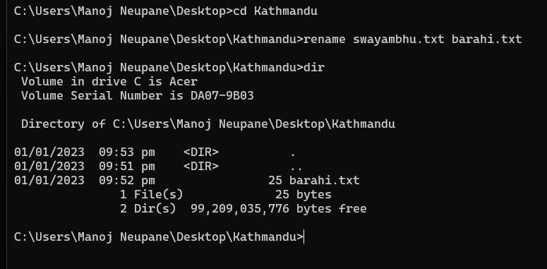

8. Create Directory Pokhara in the Desktop and move Bahari.txt of director Kathmandu in directory Pokhara.
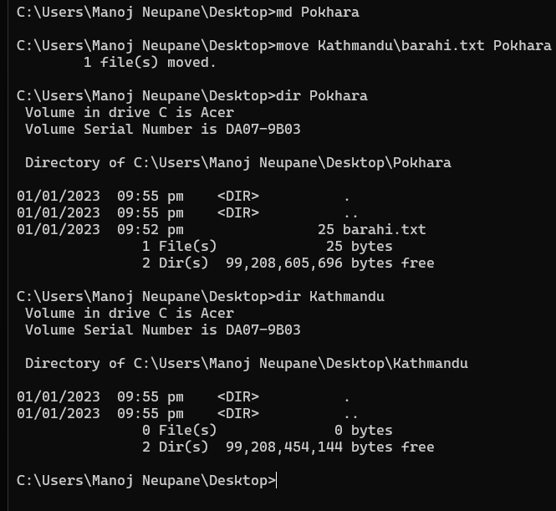

9. Write the python program in IDLE which takes two input form the user and
returns sum of the two number. Run this program from command prompt.
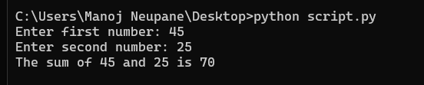

10. Run the logsim program from the command prompt.
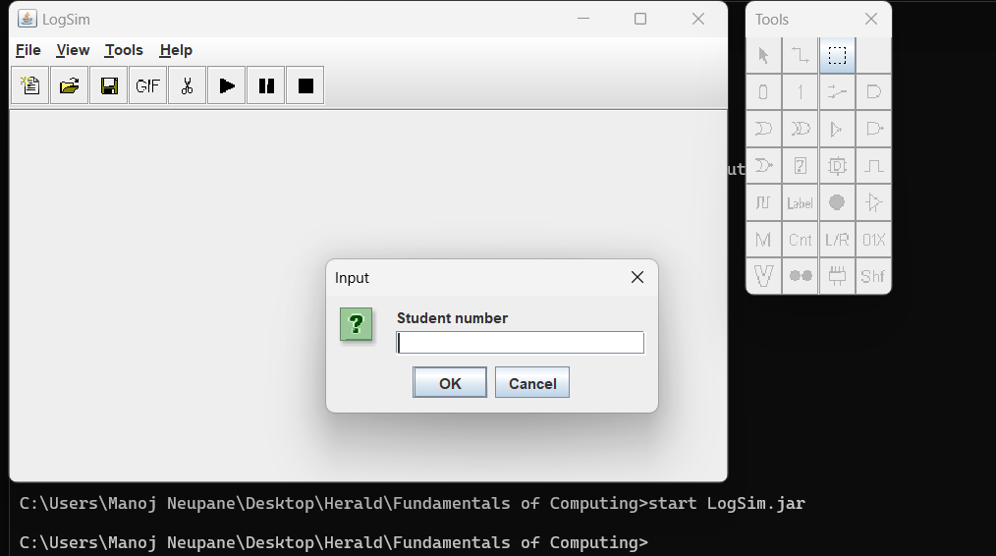

11. Create the following structure and take Screen sort. Paste your result here.
